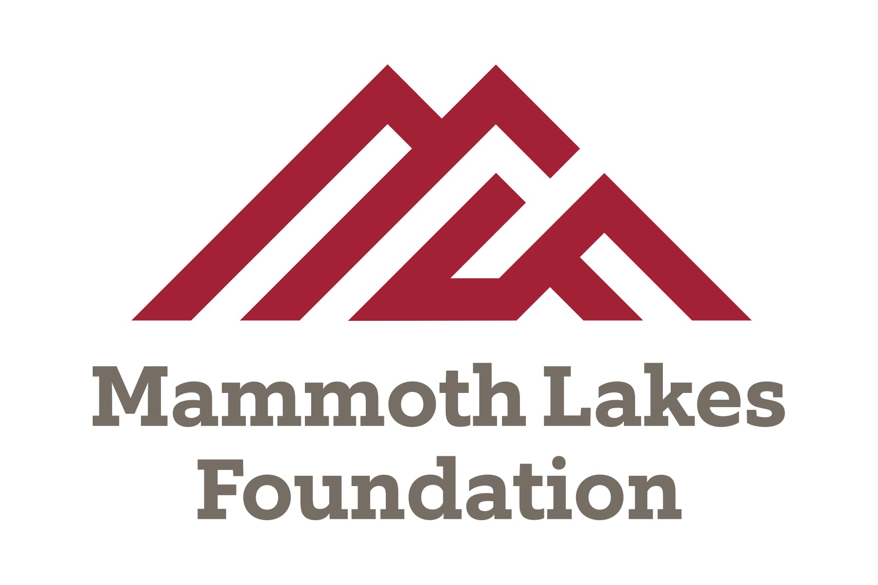

What does the scholarship provide?
Mammoth Lakes Foundation
Local Scholarship Application – 2020 Fall Semester
STUDENTS MUST REAPPLY EACH SEMESTER

For each applying spring/fall semester: $500 toward required text books and materials for enrolled courses (excludes software), in-state enrollment fees, and student representation fees (excludes non-resident tuition/enrollment fees).
CHECKLIST OF REQUIREMENTS:
- Be a Mono County Resident for the past two consecutive years or be a Mono County High School Graduate.

Provide proof of residency or submit high school transcripts
- Students must complete and submit one of the following financial aid application forms and provide proof of submission:

Free Application for Federal Student Aid (FAFSA)  CA Dream Act Application  Board of Governors Fee Waiver (BOGW)
ESCC / MLF VERIFICATION
- Students must apply for Cerro Coso’s Extended Opportunity Program and Services (EOPS). Please see information and application at: https://www.cerrocoso.edu/studentservices/access-programs/eops
ESCC / MLF VERIFICATION
- Complete matriculation services at Cerro Coso (Assessment, Orientation, Counseling and Education Plan) and provide proof of completion (see Registration Status under MyBanWeb in InsideCC - select the current term).
ESCC / MLF VERIFICATION
- Hold full-time student status (12+ units) at Cerro Coso’s Mammoth Lakes Campus for applying semester.
  - NEW APPLICANTS must enroll in Counseling 101 their first Fall semester
  - Submit class schedule for applying semester.
  - RETURNING APPLICANTS must maintain a GPA of 2.5 to continue scholarship. Grades will be reviewed at the end of each semester. ESCC / MLF VERIFICATION
- Applicant must write a brief, typed, minimum 250-word Statement Letter answering the following questions (each semester applying for scholarship):
  - Describe your academic and career goals; share relevant information on what has influenced these goals, include plans for achievement, and how receiving this scholarship will assist with those goals.
  - Additional Questions for Returning Applicants: How have you been involved in the Mammoth Lakes community? How have you grown as a result of your involvement? Please elaborate on your volunteer experience with Mammoth Lakes Foundation.
- Commit to and complete volunteer service with the Mammoth Lakes Foundation as outlined on following page.
- Participate in weekly check-ins at Cerro Coso’s Learning Resource Center (LRC) at the Mammoth campus.

Student Information (please print clearly):
First Name: Middle Initial: Last Name: Cerro Coso Student ID: @ Best Contact Phone Number: E-mail: High School / GED Completion at: Year: Current GPA: Mailing Address: City/State: Zip:
Parent Name: Parent Email Address:

For consideration, complete application with all required documentation is due on or before August 20th, 2020.

Submit your application and all required documents to Mammoth Lakes Foundation located at: 100 College Parkway, Mammoth Lakes, CA 93546

VOLUNTEER REQUIREMENTS - VOLUNTEER REQUIREMENTS Scholarship recipients are required to volunteer a total of ten (10) hours for each applying semester (20 hours per calendar school year). You may complete annual hours at one activity. Check your availability:
- Attend monthly brunches
- MLF Office administrative/maintenance assistance
Required monthly scholarship brunches, typically held the last Friday of each month, will count toward your volunteer requirements. In addition, you will receive emails from us regarding other volunteer opportunities throughout the semester.
Mammoth Lakes Foundation Local Scholarship - Rules and Eligibility Requirements
The purpose of this scholarship is to encourage local Mono County students and residents to enroll in and attend classes at the Mammoth Campus of Cerro Coso Community College, to achieve their higher educational goals.
The scholarship pays up to $500 for books/materials for enrolled courses, student representation, and in-state enrollment fees. The scholarship does not pay for course software, optional textbooks, computers, pens, notebooks, calculators, room, board, living expenses etc. The scholarship only covers what a semester “Course Schedule” describes as required materials for each course.
Books are to be purchased through an online account at Barnes & Noble. Instructions for online textbook ordering will be provided upon scholarship approval.
The scholarship is only available to students enrolled in courses at the Mammoth Campus. The scholarship does not allow students to enroll in on- line courses unless a course is needed to graduate or to finish an educational program and that class is not offered in the student’s final semester. The scholarship will allow students to take classes at the Bishop Campus only if required courses are not offered at the Mammoth Campus in a given semester. Any exceptions must be verified and approved by a Cerro Coso counselor.
To be eligible to receive a MLF Scholarship, a student must have graduated from a Mono County High School or have been a resident of Mono County for the last two years. Students must be California residents. Students who previously left the State of California must meet the one-year residency requirement to be eligible. Documentation may be requested for verification. All awarded recipients must complete all committed volunteer service at the Mammoth Lakes Foundation each semester. Students must be making satisfactory academic progress in college of at least a GPA of 2.5 and complete each semester with full-time (12+ units from on-ground courses) progress toward an educational goal up to a maximum of 60 completed units. Each recipient of the scholarship must meet with an academic advisor before the beginning of each semester to ensure the student’s educational progress is being maintained. A scholarship student must approve the release of enrollment information to the

Mammoth Lakes Foundation to qualify for the scholarship.
(STUDENT INITIAL)

Students must reapply every semester to receive the MLF Scholarship. A student who fails to maintain the conditions of continuing eligibility as required above will no longer be eligible for the scholarship. All students who fail to meet the requirements will be dropped from the scholarship and will no longer receive financial support. Eligibility will only be reinstated after the student reimburses the Mammoth Lakes Foundation for the failed or dropped class(es) (if any amount was paid by MLF). To qualify for reinstatement for scholarship support in a subsequent semester,

the student must pay any balance and meet scholarship standards as stated above.
(STUDENT INITIAL)

The role of the scholarship student is to represent the Foundation and the College with integrity and behavior conducive to the values of the Foundation. Inappropriate behavior exhibited by the scholarship student is grounds for the revocation of the scholarship to include tuition, books

and housing.
(STUDENT INITIAL)

To assist the MLF in this application process and facilitate future marketing and development, we are asking for your permission to use photos/ videos of you and your statement letter in any promotional advertisement. By initialing here, you are giving MLF permission to take and use

photos/videos of you and use your statement letters͘. The terms of this scholarship are subject to amendment.
(STUDENT INITIAL)

“I attest that the above information is correct. False information will result in the loss of my scholarship.”

Signature of Student Date

OFFICE USE ONLY
Received by: Date Received: Action Taken:

For further information on the MLF Local Scholarship, please contact the Mammoth lakes Foundation:
by phone (760) 934-3781 or by email info@mammothlakesfoundation.org

Submit your application and all required documents to Mammoth Lakes Foundation located at: 100 College Parkway, Mammoth Lakes, CA 93546

